**1. Project Overview**

This project aims to develop a system that processes images from a driving simulation dataset and generates responses using a Large Language Model (LLM). The system will involve image upload, potential image modifications, and LLM-based analysis and response generation.

**2. Key Components**

**2.1 Data Input**

* **Source:** DriveSim dataset (https://github.com/sreeramsa/DriveSim/tree/main)
* **Type:** Images from driving simulations

**2.2 Image Processing Pipeline**

* Upload mechanism for dataset images
* Potential image modification and distortion pipelines (details to be determined)

**2.3 LLM Integration**

* Selection of appropriate LLM for image analysis and response generation
* API or interface for sending processed images to the LLM
* Mechanism for receiving and parsing LLM responses

**3. Workflow**

**1. Image Upload:** System receives images from the DriveSim dataset.

**2. Image Processing:** Apply any necessary modifications or distortions to the images.

**3. LLM Analysis:** Send processed images to the chosen LLM.

**4. Response Generation:** Receive and process the LLM's response to the image.

**5. Output:** Present the LLM's response in a suitable format.

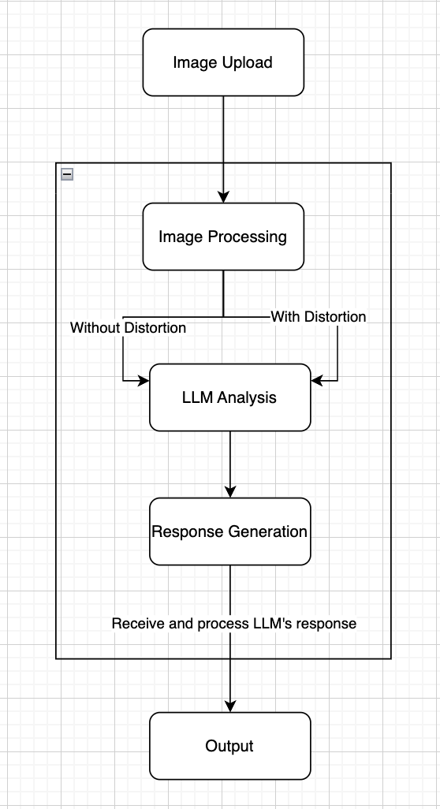

**4. Technical Requirements**

* Image processing library (e.g., Pillow)
* LLM API or integration (e.g., Google Gemini)
* Frontend interface for uploading images and displaying results(e.g., Streamlit)